Acceptance Testing

|  |  |  |
| --- | --- | --- |
| **User** | **Test description** | **Result** |
| 1 | Testing of basic game functions such as input into the matrix | Test passed. Text boxes take in input and are modifiable |
| 2 | Testing of scoring functions | Test failed. Further progress needed with scoring method |
| 3 | Testing of time keeping function | Test passed. The game displays current system time and allows the user to see time elapsed |

Screenshots for testing:

User 1: 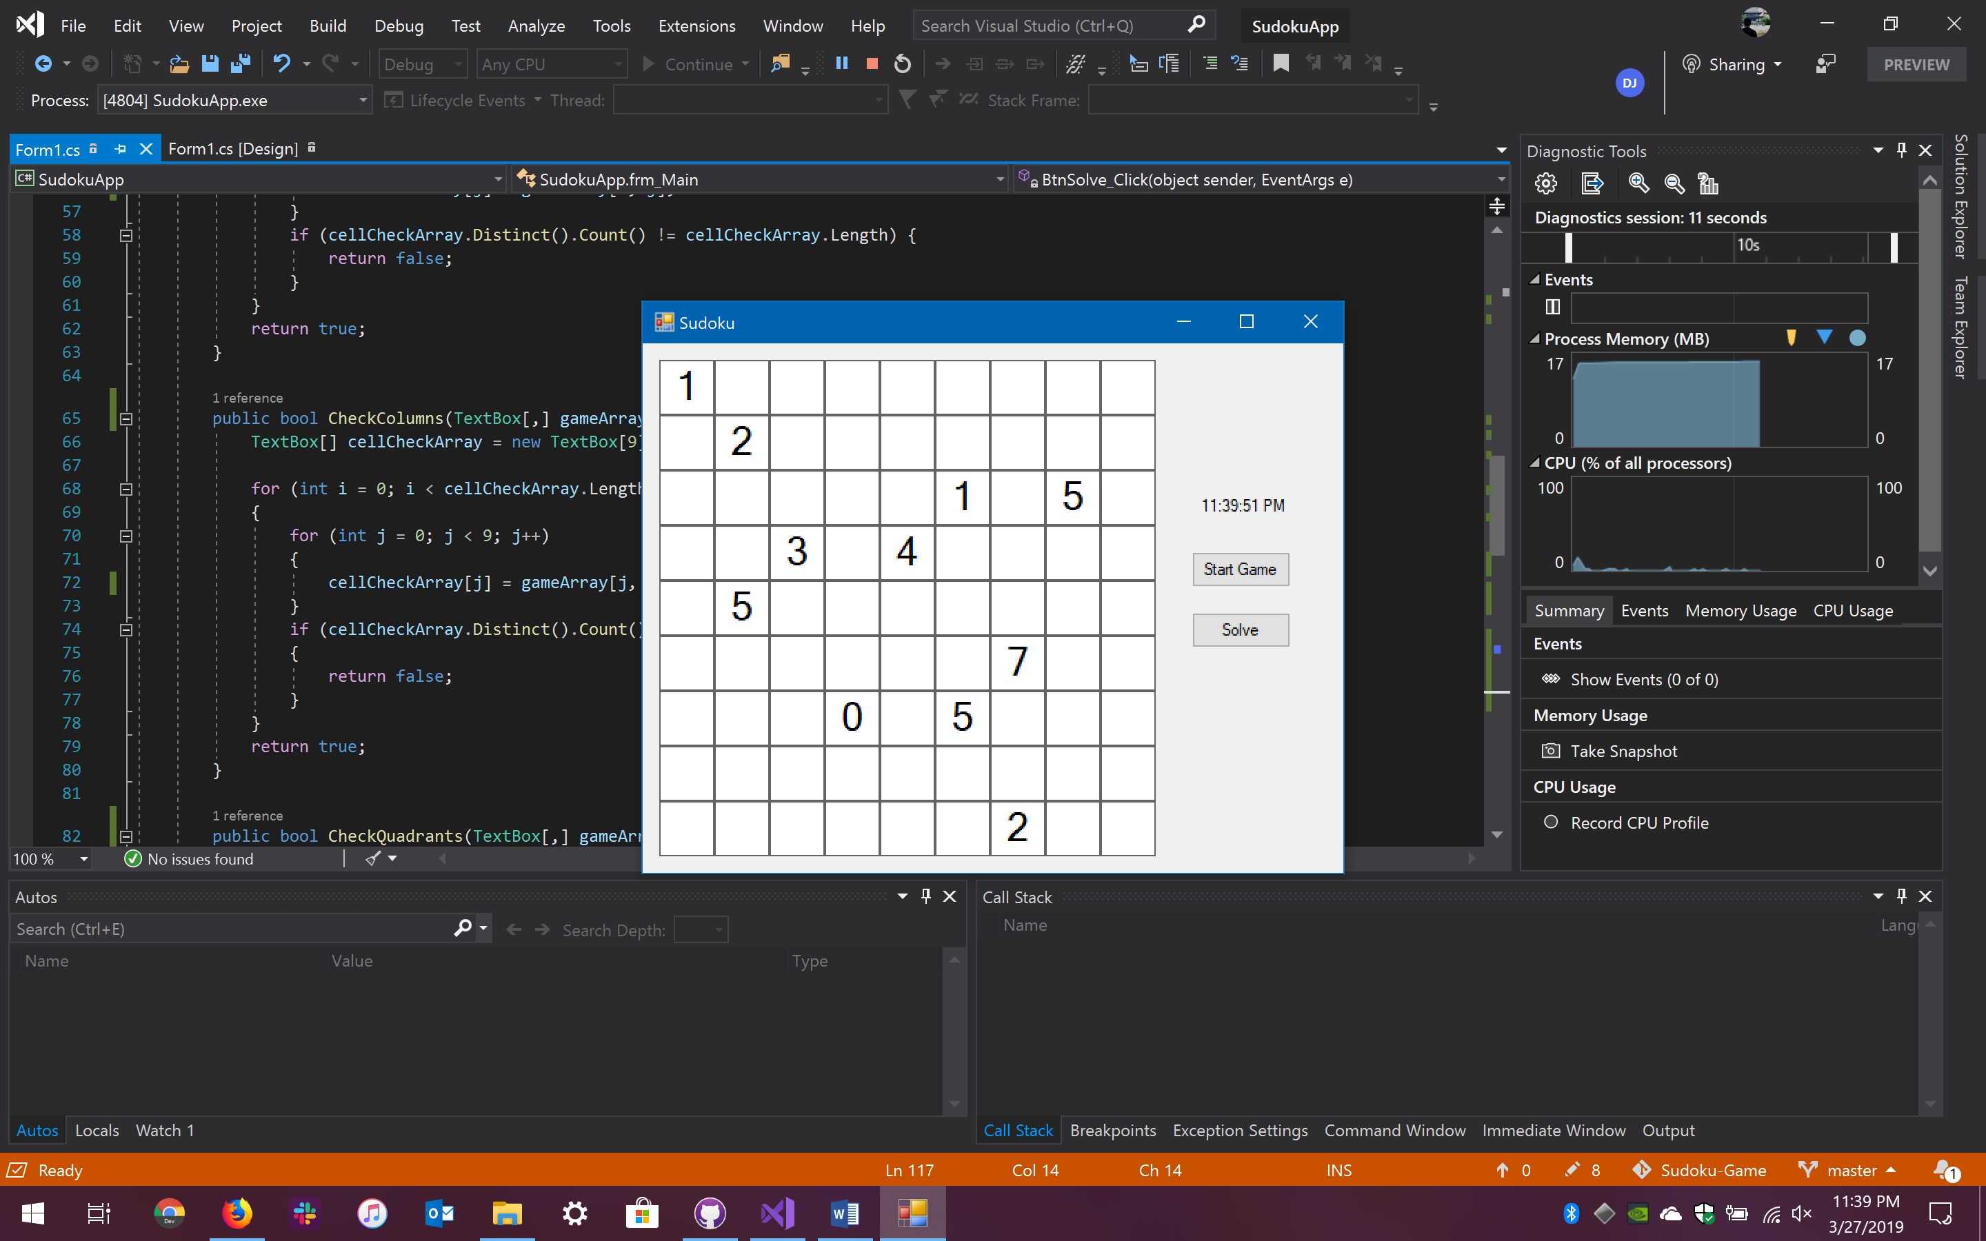

User 2:

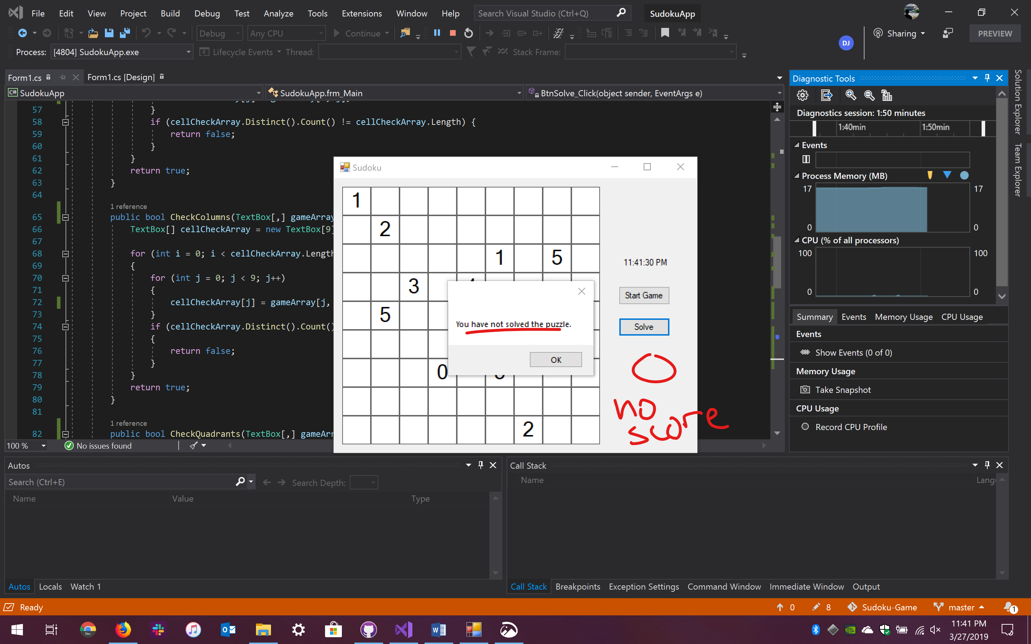

User 3:

